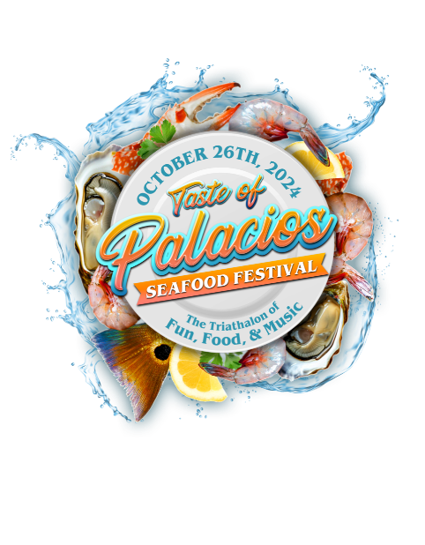
TASTE of PALACIOS – SEAFOOD FESTIVAL
Volunteer Information

Event Date: October 26th
Start Time: 11:00 AM to 6:00 PM
Location: Main & 4th Street, Palacios, TX

I would like to volunteer to help with the Taste of Palacios – Seafood Festival
- Setup
- Winery Tasting Area
- Food Tent
- Sell Tickets
- Clean-up
- Other _____________________

Name: Click or tap here to enter text. Phone No. Click or tap here to enter text.
Email:____Click or tap here to enter text.
Address:_Address City: City State: State
T-shirt size: Choose an item.

If you would like more information, please contact Mary Katherine Niccolai at piratequeendesigns@gmail.com or DC Dunham at dc@dcdunham.com or 979-479-0165.

Thanking you in advance for your help.

